Fixed-wing Lesson 5 Fixed-wing Autopilot

[1. Lesson Introduction](https://classroom.udacity.com/nanodegrees/nd787/parts/ee7d5970-d39c-4355-952e-ce760e701827/modules/2dd61f74-6310-4f18-98b2-e4a9a9450f85/lessons/78e5fe68-902d-4cfb-bd71-5f8d19fd8ead/concepts/5d97fa2c-973a-4f82-bd9f-52d3a5f6ad8c)

<https://www.youtube.com/watch?v=XI9c-HfW1WQ>

[2. Fixed Wing Trajectories](https://classroom.udacity.com/nanodegrees/nd787/parts/ee7d5970-d39c-4355-952e-ce760e701827/modules/2dd61f74-6310-4f18-98b2-e4a9a9450f85/lessons/78e5fe68-902d-4cfb-bd71-5f8d19fd8ead/concepts/723f3a78-0ee9-4d6a-9d74-30102c6c7a30)

<https://www.youtube.com/watch?v=tQkk_SCNzDQ>

[3. System Architecture](https://classroom.udacity.com/nanodegrees/nd787/parts/ee7d5970-d39c-4355-952e-ce760e701827/modules/2dd61f74-6310-4f18-98b2-e4a9a9450f85/lessons/78e5fe68-902d-4cfb-bd71-5f8d19fd8ead/concepts/b0f1e6ba-d9ad-4b91-a33f-abffc9f1aecc)

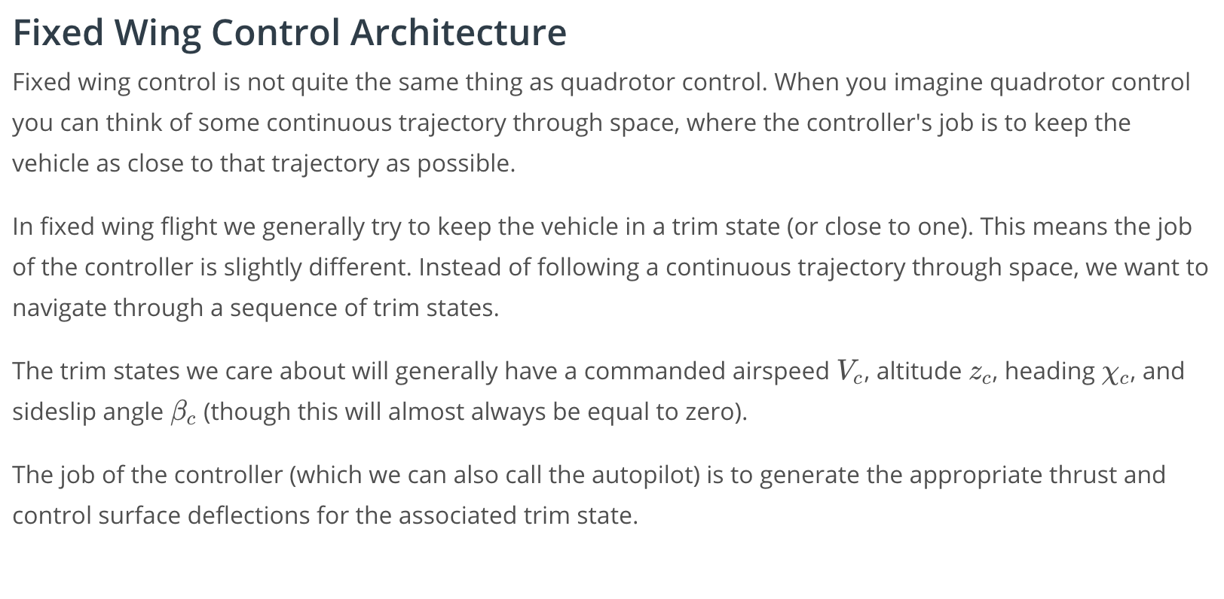

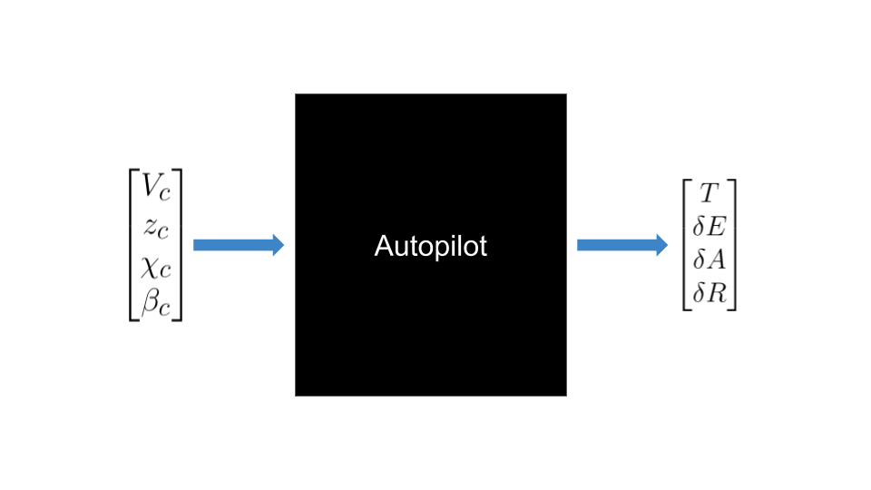

## **Longitudinal and Lateral-directional Autopilots**

As you've seen in the last few lessons, we can break the dynamics of fixed wing flight into two smaller problems: longitudinal motion and lateral-directional motion. This allows us to break our control problem into two smaller problems as well.

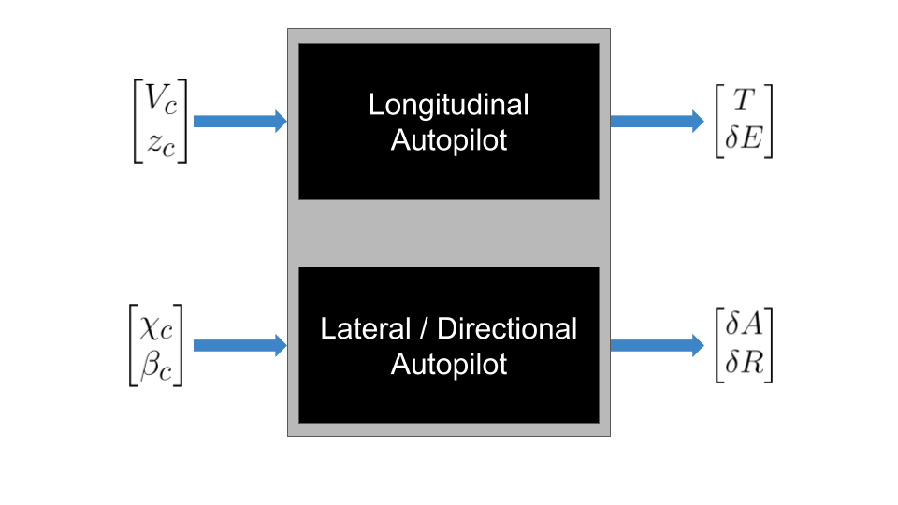

We'll be discussing this diagram more in the rest of this lesson. Ultimately, the control diagram that we use will look something like this:

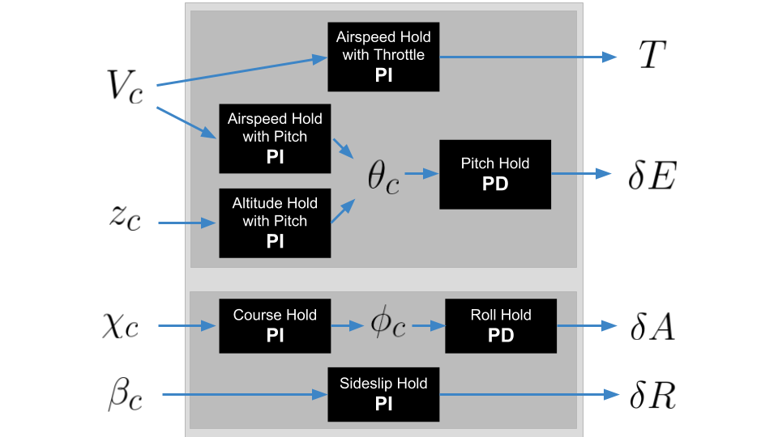

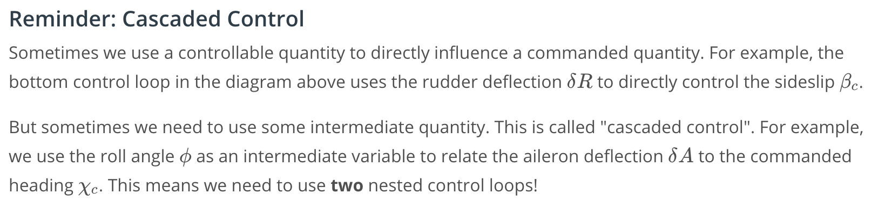

If you want an additional refresher on cascaded control, go back to the video called [Intro to Cascaded Control](https://classroom.udacity.com/nanodegrees/nd787-beta/parts/68999b8f-3344-41c6-8229-7ab110643991/modules/8db4f643-8d79-473f-a645-b7dd00452972/lessons/adf9cc77-d52c-4958-810d-89ddc5997437/concepts/0261dae7-6409-4aac-84dc-0357ae2259a6?contentVersion=1.0.0) from the module on quadrotor control.

### **Reminder: Fixed Wing Cheat Sheet**

You can find all of the equations for this module in the [Fixed Wing Cheat Sheet](https://www.overleaf.com/read/cvqmtzyhqjnj).

[4. Controller Design Principles](https://classroom.udacity.com/nanodegrees/nd787/parts/ee7d5970-d39c-4355-952e-ce760e701827/modules/2dd61f74-6310-4f18-98b2-e4a9a9450f85/lessons/78e5fe68-902d-4cfb-bd71-5f8d19fd8ead/concepts/204b6203-1f97-4d63-ad7d-8db2f57ab10a)

<https://www.youtube.com/watch?v=vWJxmSVaT1c>

[5. Lateral Autopilot](https://classroom.udacity.com/nanodegrees/nd787/parts/ee7d5970-d39c-4355-952e-ce760e701827/modules/2dd61f74-6310-4f18-98b2-e4a9a9450f85/lessons/78e5fe68-902d-4cfb-bd71-5f8d19fd8ead/concepts/806a6b3d-00d7-483b-bf95-034d2a7fcbdd)

<https://www.youtube.com/watch?v=xHw6zdfc2u0>

[6. Course Hold](https://classroom.udacity.com/nanodegrees/nd787/parts/ee7d5970-d39c-4355-952e-ce760e701827/modules/2dd61f74-6310-4f18-98b2-e4a9a9450f85/lessons/78e5fe68-902d-4cfb-bd71-5f8d19fd8ead/concepts/c44bbf58-a38c-48a6-9e51-a6fb7d0cc722)

# **Course Attitude Hold**

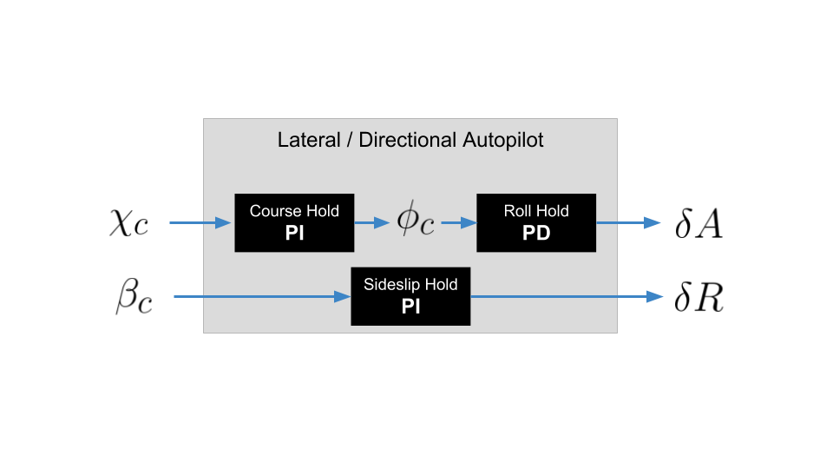

[The course-attitude hold controller is shown in the upper left.](https://classroom.udacity.com/nanodegrees/nd787/parts/ee7d5970-d39c-4355-952e-ce760e701827/modules/2dd61f74-6310-4f18-98b2-e4a9a9450f85/lessons/78e5fe68-902d-4cfb-bd71-5f8d19fd8ead/concepts/c44bbf58-a38c-48a6-9e51-a6fb7d0cc722#)

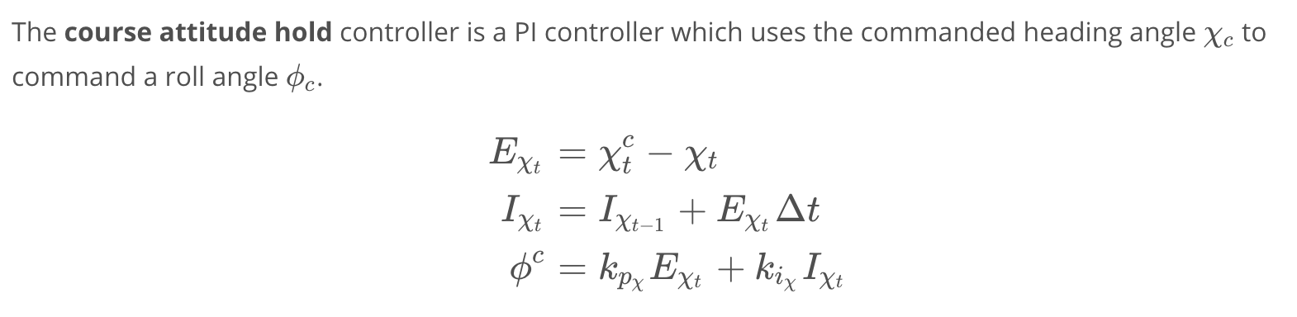

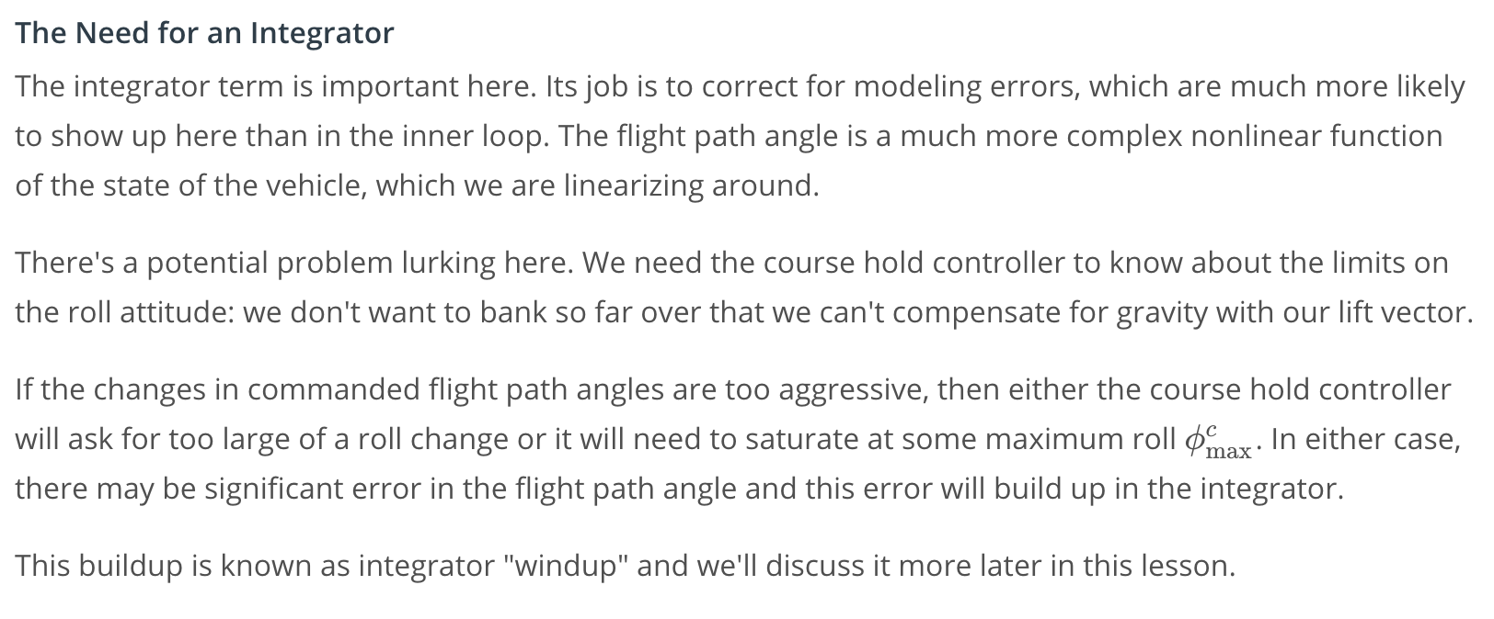

#### **What about a D term?**

We don't need a derivative term. Remember, the role of the derivative term is to damp the response of the system, but in a cascaded system we want to run the outer loop much more slowly than the inner loop.

The reason for this is that each control loop has finite response time, and the outer loop has to give the inner loop time to respond to the last command before sending the next one. If we run the outer loop too slowly, the system will not be responsive enough. If we run the outer loop too quickly the system is likely to be unstable, as the inner loop will constantly be chasing what the outer loop tells it to do.

Since the outer loop is running much more slowly than the inner loop, it shouldn't need any damping.

[7. Inner Loops: Roll and Sideslip Hold](https://classroom.udacity.com/nanodegrees/nd787/parts/ee7d5970-d39c-4355-952e-ce760e701827/modules/2dd61f74-6310-4f18-98b2-e4a9a9450f85/lessons/78e5fe68-902d-4cfb-bd71-5f8d19fd8ead/concepts/a330dc6a-87c5-4cc3-a96b-771f049facff)

# **Roll Attitude Hold**

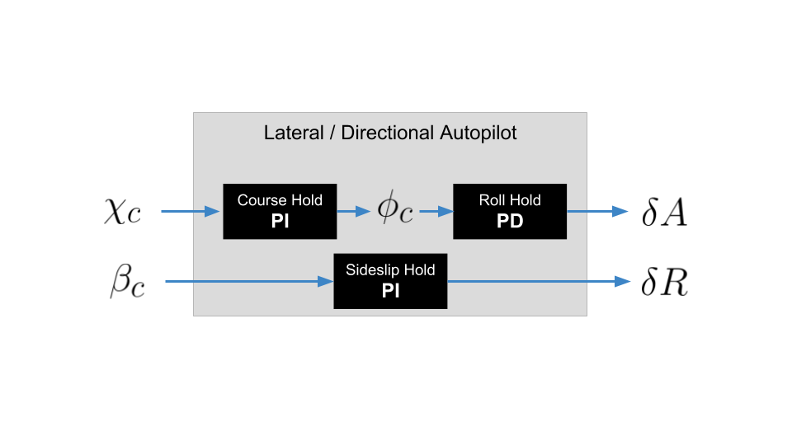

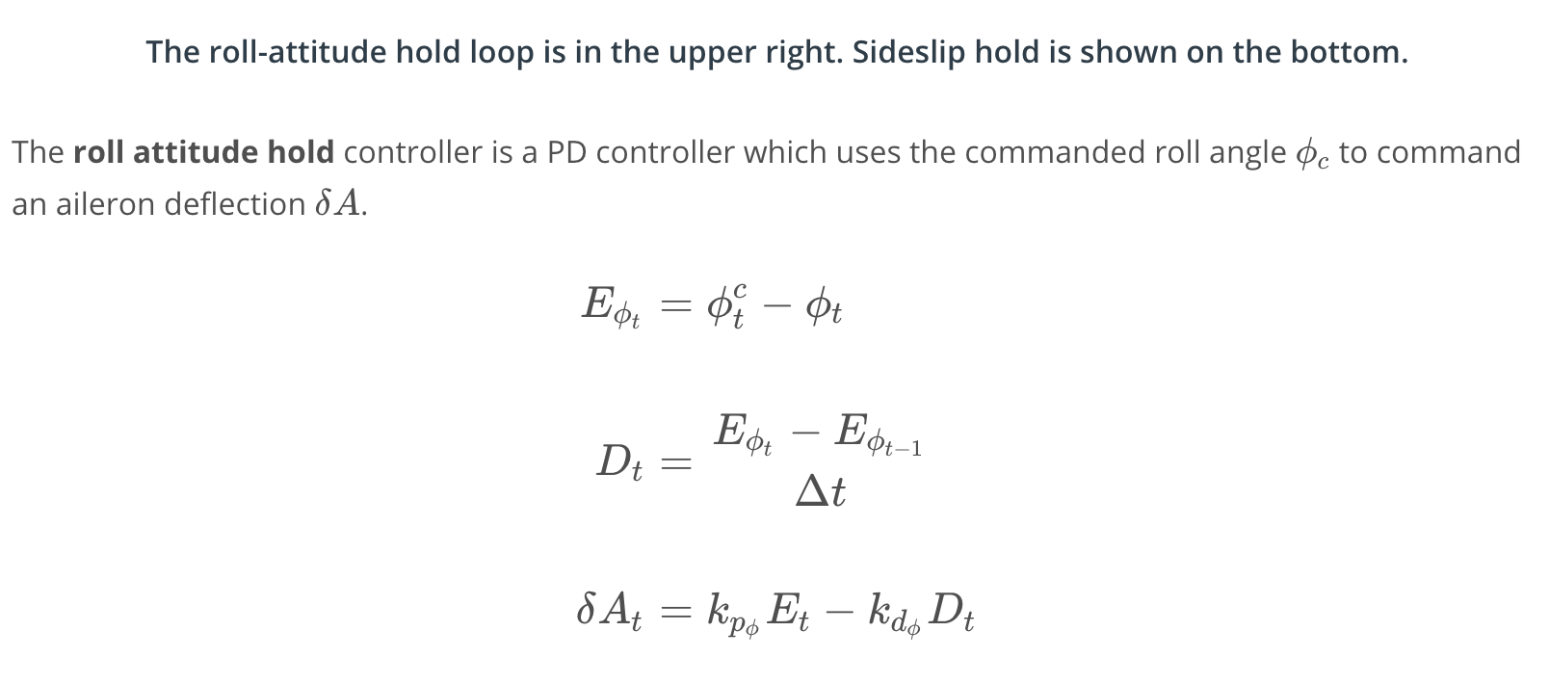

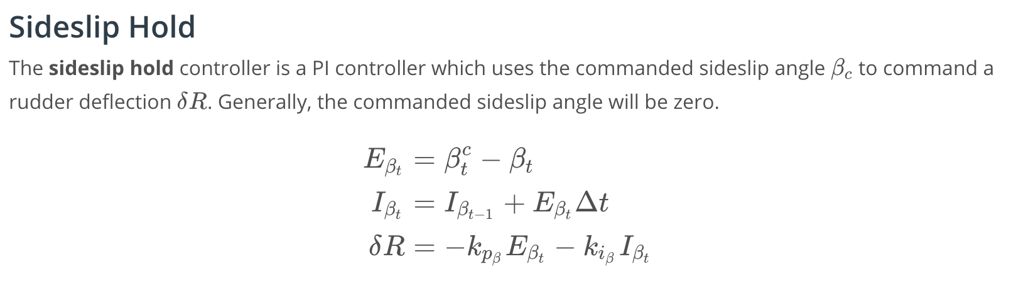

[8. Longitudinal Autopilot](https://classroom.udacity.com/nanodegrees/nd787/parts/ee7d5970-d39c-4355-952e-ce760e701827/modules/2dd61f74-6310-4f18-98b2-e4a9a9450f85/lessons/78e5fe68-902d-4cfb-bd71-5f8d19fd8ead/concepts/43124fb9-56ed-4202-8d24-6c15b76a6387)

<https://www.youtube.com/watch?v=KRooEa015ms>

[9. Longitudinal Control Loops](https://classroom.udacity.com/nanodegrees/nd787/parts/ee7d5970-d39c-4355-952e-ce760e701827/modules/2dd61f74-6310-4f18-98b2-e4a9a9450f85/lessons/78e5fe68-902d-4cfb-bd71-5f8d19fd8ead/concepts/fd51fb8f-a2ed-4421-8299-208823ab09c5)

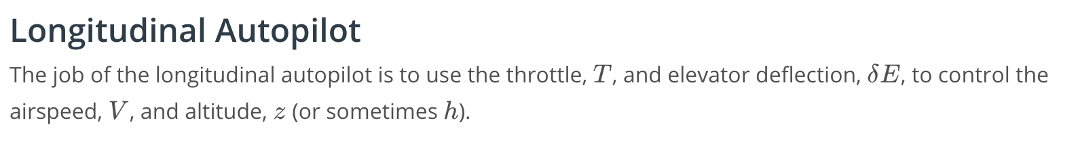



But there's some redundancy here, since the throttle and the elevator deflection can influence both the airspeed and altitude. We resolve this redundancy by dividing flight into four "zones":

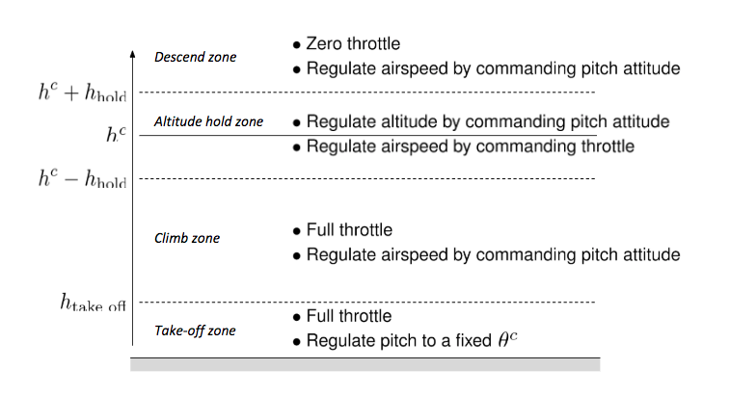

We can model this as a state machine, where transitions between states happen when the vehicle crosses between zone boundaries.

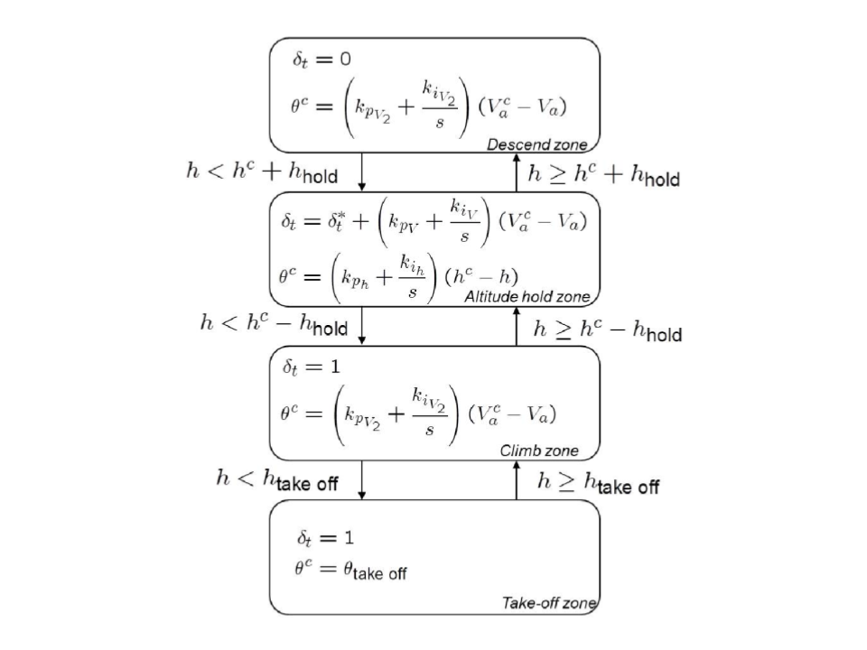

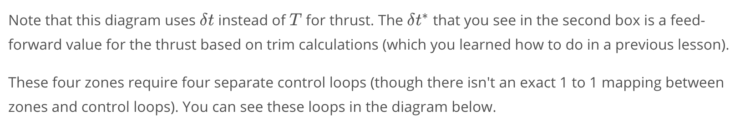

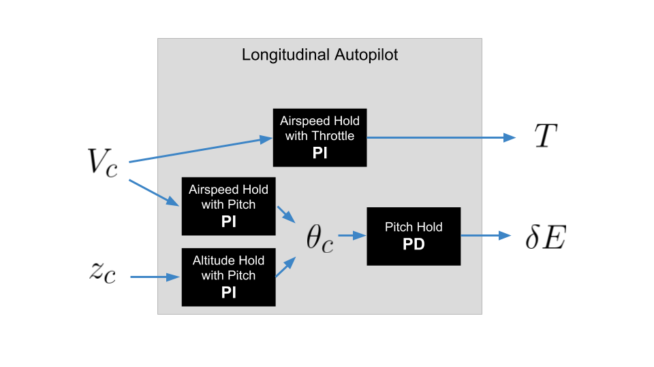

[10. Autopilot Tuning](https://classroom.udacity.com/nanodegrees/nd787/parts/ee7d5970-d39c-4355-952e-ce760e701827/modules/2dd61f74-6310-4f18-98b2-e4a9a9450f85/lessons/78e5fe68-902d-4cfb-bd71-5f8d19fd8ead/concepts/0066420d-b1c2-47e6-b980-ee8fa0d150ae)

# **Autopilot Tuning**

Controller tuning can be tricky. In this section we'll provide some general guidelines to help.



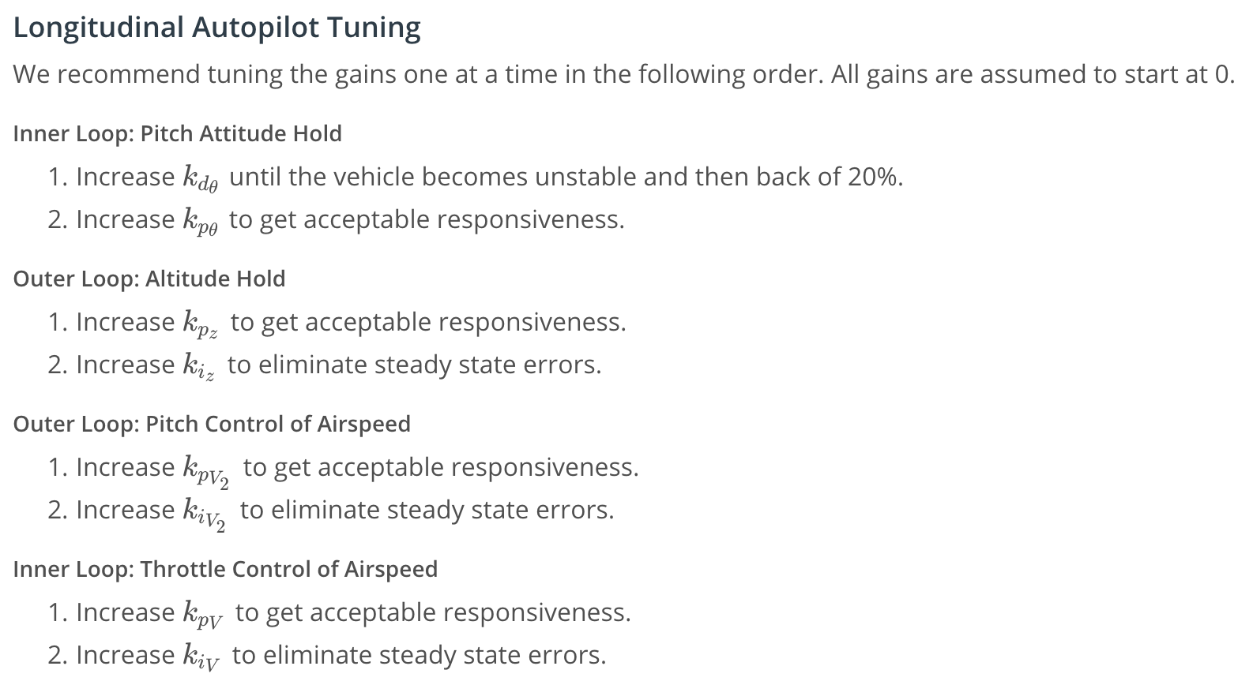

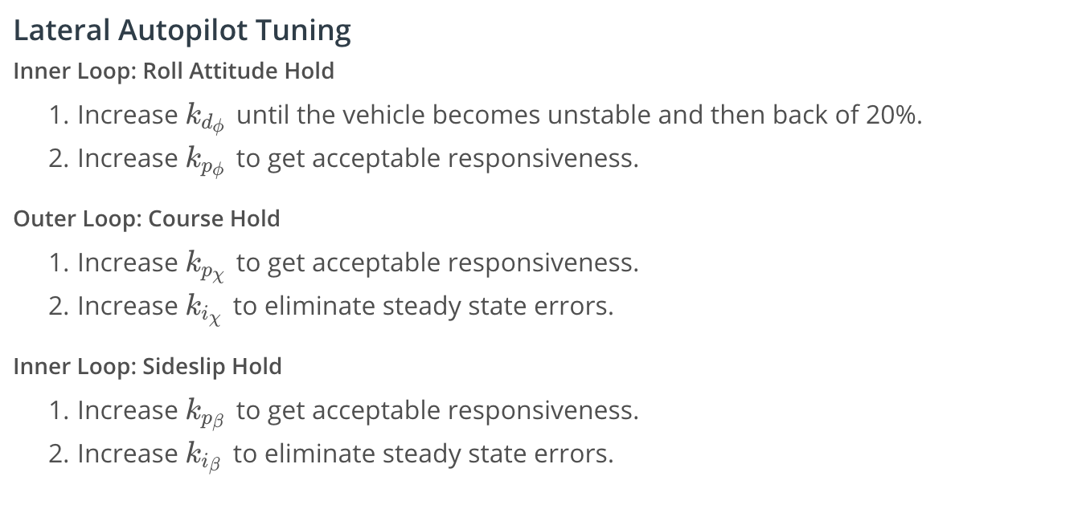

[11. Integrator Windup](https://classroom.udacity.com/nanodegrees/nd787/parts/ee7d5970-d39c-4355-952e-ce760e701827/modules/2dd61f74-6310-4f18-98b2-e4a9a9450f85/lessons/78e5fe68-902d-4cfb-bd71-5f8d19fd8ead/concepts/5068563a-9a51-4b26-81a7-445aca6edfa5)

[Integrator Windup.ipynb](https://viewhjgnv1bnzx.udacity-student-workspaces.com/notebooks/Integrator%20Windup.ipynb)

[12. Conclusion](https://classroom.udacity.com/nanodegrees/nd787/parts/ee7d5970-d39c-4355-952e-ce760e701827/modules/2dd61f74-6310-4f18-98b2-e4a9a9450f85/lessons/78e5fe68-902d-4cfb-bd71-5f8d19fd8ead/concepts/210e4552-aa81-4b40-9f01-dd5b1c452c73)

<https://www.youtube.com/watch?v=NoAimkRksso>